**Usability Guide - V0**

**Rice Management System Design Sprint**

Conducted by: Nguyen Chi Thao

Date: August 10, 2024

**Setup**

* **Discussion Guide** Printed or a New File is Copied



* Known Respondent Information is Filled In



* Prototype is Open and Running



**In-Person Sessions**

* Activities are Printed and Ready



* Respondent Post-It Card Created (with respondent ID, Date, Location, etc.)



* Recording Devices are Running



* If Remote Viewers: Link Shared with the Team



**Remote Sessions**

* Session Link Created and Shared with the Respondent



* Recording Button is Clicked and Running



* If Remote Viewers: Link Shared with the Team



* Screen Sharing is Activated and Mouse Control is Granted



**Introduction Script**

Thank you for taking the time to speak with us today. We’re developing a new Rice Management System aimed at helping farmers and distributors efficiently manage rice production and sales. This phase of research is to explore and validate our approach to what this system should look like.

During this session, we’ll ask a few open-ended questions and then walk you through some early prototypes.

Everything you share will be kept strictly anonymous and confidential.

There are no right or wrong answers to our questions! We want to understand how you interpret and understand our designs. Please talk out loud as much as possible about what’s on your mind during these tasks. Try to be as honest as possible, I promise, you won’t hurt our feelings.

{If recording: We’ll be recording video, audio, and notes for my own memory and to share with my team, but everything you say is strictly confidential and all data will be securely encrypted. We might share anonymized quotes or aggregate statistics from these sessions as we develop the system. We’ll never link this data back to your name publicly. Does this make sense and are you okay with it?}

[If offering incentive: You’ll receive a [$__ gift card, cash, discount] at the end of this session. [If gift card: We’ll email the gift card to ____.] Is this okay?

Any questions before we start?

**Opening Ethnography**

**Experience with Rice Management**

* **How do you currently manage your rice inventory?**
  + Are you using any software tools?
  + If not, how do you keep track of inventory?
* **What are the biggest challenges you face in managing rice production?**
  + Are there any specific pain points you experience regularly?
* **Can you describe the last time you had to fulfill a large order?**
  + What steps did you take?
  + How did you ensure accuracy and timeliness?
* **How do you currently manage your sales?**
  + Do you track sales manually or use any tools?
  + How do you handle payments and invoices?

**Usability Tasks**

@TODO Create your task flow note guide using the following template as a guide.

| **Section** | **Task Point** | **Notes** | **Pass/Fail** |
| --- | --- | --- | --- |
| **Field Entry** | Access Field Data Section | The user was able to locate and access the field data section without any difficulty. | pass |
| **Harvest Tracking** | Log Harvest Data | The user logged harvest data successfully, but there was some confusion regarding the input units. | needs improvement |
| **Inventory Management** | Update Inventory After Harvest | The user updated the inventory based on the latest harvest but missed some input fields. | needs improvement |
| **Order Processing** | Place New Order | The user placed a new order, but required assistance for understanding product codes. | FAIL |
| **Sales Tracking** | Review Sales Performance | The user reviewed sales performance but found the charts hard to interpret. | FAIL |
| **Invoice Management** | Generate and Send Invoice | The user generated and sent an invoice seamlessly and understood all the steps. | pass |

Wrap Up

• Have I covered everything you expected in this session?

• Do you have any additional questions or suggestions for us?

Thank you so much for taking the time to participate in this research session. Your insights are incredibly valuable, and they will help us refine and improve the Rice Management System to better meet the needs of users like you. Your feedback today will contribute directly to making the system more effective and user-friendly for managing all aspects of rice production and sales.

If we continue to develop and iterate on this prototype, would it be okay for us to reach out to you for further input in the future?

**Note**

Nguyen Chi Thao Note link TODO

* 1. Miro report:  
     https://miro.com/welcomeonboard/SUs1SUxyeG1KbzRWOWRoS1V1eVR6bEd6cjh1UnJMeVh3SDJuTFRiakg0bzBFQ2hRQXNHOWNZcndVeER3SU1naHwzNDU4NzY0NTk2NzEzNDQxMjY1fDI=?share_link_id=419708285792

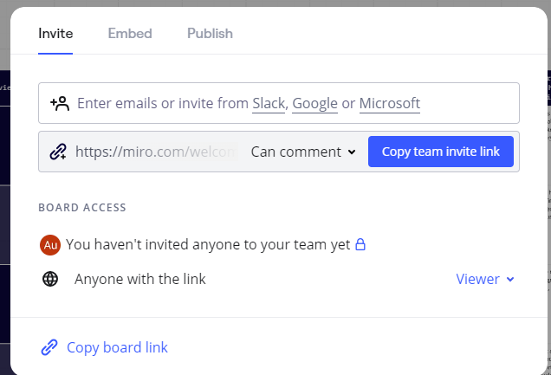



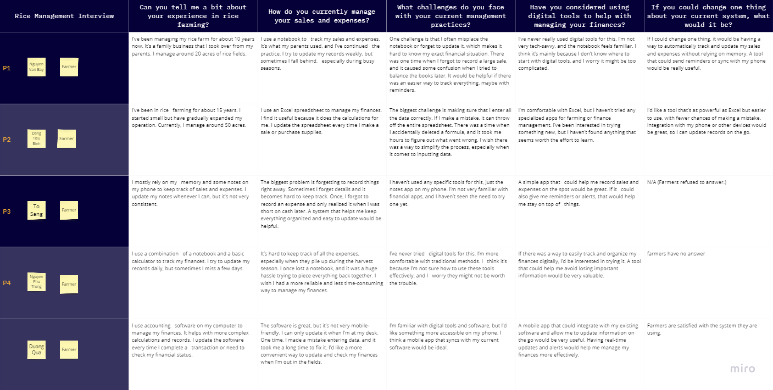

* 1. Figma

<https://www.figma.com/design/omfhpQXjVtl09UWFDpR2Zt/Digital-Prototype?node-id=0-1&t=Nv78euN9xqpl2Lal-1>

Digital Prototype: “I need to pay a fee to be able to assign a link to the sign-in button.”

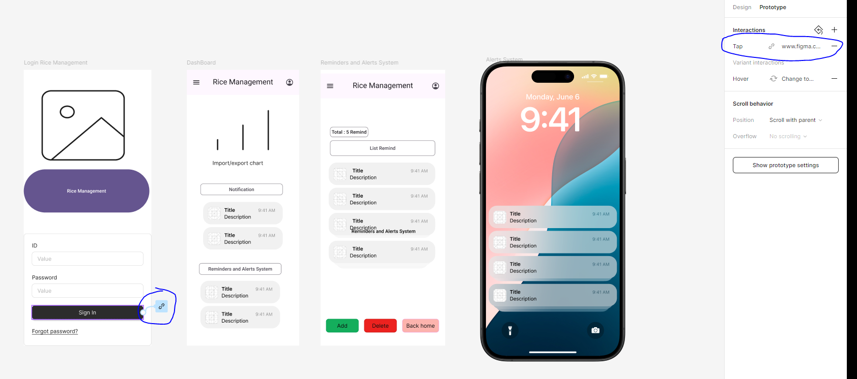

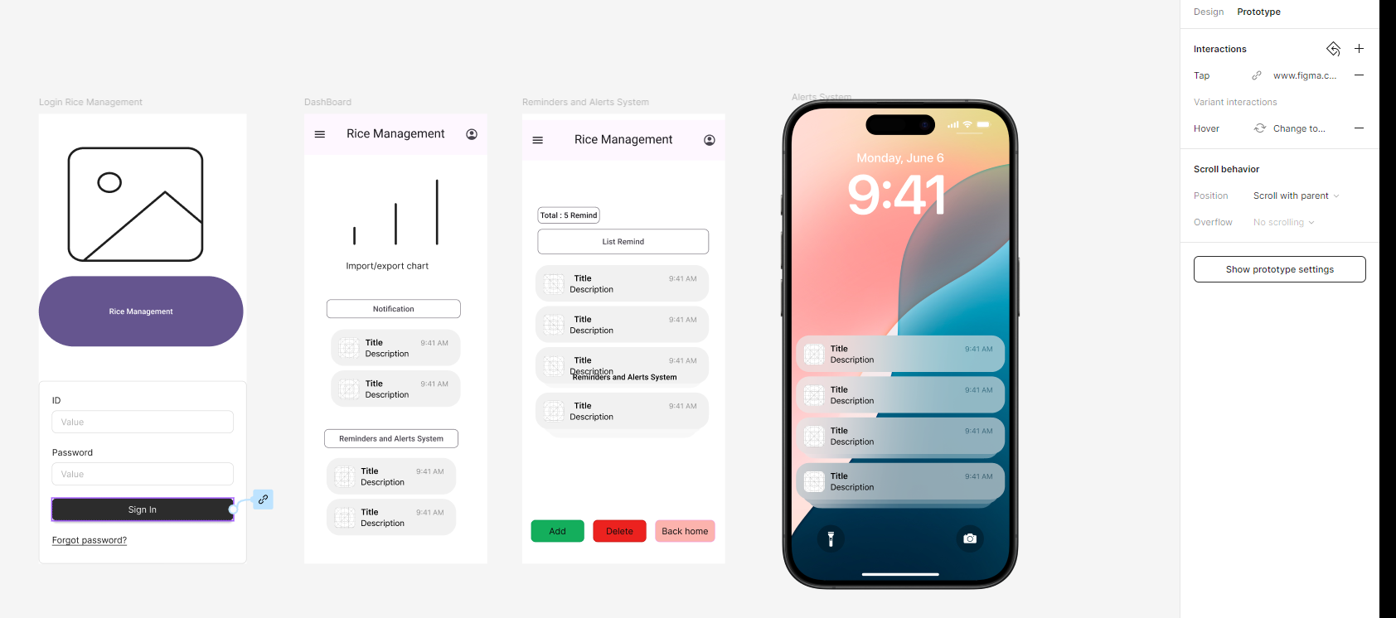

**Usability Study and Design Iteration**

Miro

<https://miro.com/welcomeonboard/SUs1SUxyeG1KbzRWOWRoS1V1eVR6bEd6cjh1UnJMeVh3SDJuTFRiakg0bzBFQ2hRQXNHOWNZcndVeER3SU1naHwzNDU4NzY0NTk2NzEzNDQxMjY1fDI=?share_link_id=880999648057>

Drive share link Drive

<https://drive.google.com/drive/folders/1WZGhS0D_XedpHkNREX2zb9U9gPgMR5E1?usp=sharing>

Figma Protye Publish  
<https://www.figma.com/proto/omfhpQXjVtl09UWFDpR2Zt/Digital-Prototype?node-id=18-348&t=Nv78euN9xqpl2Lal-1>  
  
Publish Figma  
https://www.figma.com/@ricemanagement.